**Lab Exercises**

Class: Name: StuID:________________

Date: Score:

**Lab Exercise — Polymorphic Banking**

**I Lab Objectives**

In this lab, you will practice:

1. Creating an Account base class that contains virtual functions and derived classes SavingsAccount and CheckingAccount.
2. Defining virtual functions.
3. Calling virtual functions.
4. Downcasting with a pointer with the dynamic_cast operator.

**II Description of the Problem (译文见教材P419 12.14)**

Develop a polymorphic banking program using the Account hierarchy created in Exercise 11.10. Create a vector of Account pointers to SavingsAccount and CheckingAccount objects. For each Account in the vector, allow the user to specify an amount of money to withdraw from the Account using member function debit and an amount of money to deposit into the Account using member function credit. As you process each Account, determine its type. If an Account is a SavingsAccount, calculate the amount of interest owed to the Account using member function calculateInterest, then add the interest to the account balance using member function credit. After processing an Account, print the updated account balance obtained by invoking base class member function getBalance.

**III Sample Output**

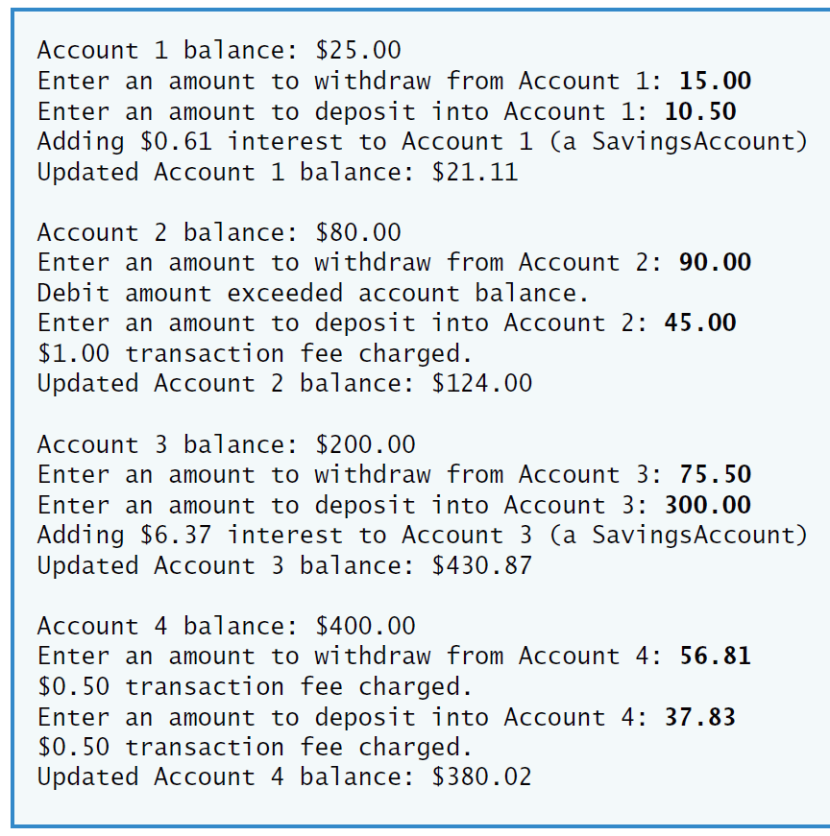

**IV Problem-Solving Tips**

1. To achieve polymorphism, declare the functions that should be called polymorphically as virtual. To indicate a virtual function within a class definition, add “virtual” before the function prototype. When the virtual functions are redefined in a derived class, those member function prototypes should also be preceded by the keyword virtual as a good programming practice.
2. To determine if a pointer to an Account object is actually pointing to a SavingsAccount object, downcast it to a SavingsAccount * using the dynamic_cast operator. If the pointer returned by this operation is not the null pointer (i.e., 0) then the object is a SavingsAccount object and that pointer can be used to access members unique to class SavingsAccount.
3. Remember that your compiler may require you to enable run-time type information (RTTI) for this particular project before this program will run correctly.

**V Your Solution**